Grocery Tracker Program

John Vowcicefski

**Introduction**

**Overview:**

The code is designed to manage a list of grocery items and their frequencies. It reads data from an input file, provides a menu to the user to perform various operations, and can create a backup of the data.

**Data Structure:**

The code uses a map (often called a dictionary or associative array in other languages) named groceryMap to store grocery items as keys and their frequencies as values.

Loading Data (loadData function):

This function reads data from a file named "CS210_Project_Three_Input_File.txt".

For each line in the file, it reads an item name and its quantity.

It then updates the groceryMap by adding the quantity to the existing value for the item. If the item doesn't exist, it's added to the map.

Listing Items (listItems function):

This function displays all the items in the groceryMap along with their frequencies.

Displaying Histogram (displayHistogram function):

This function visually represents the frequency of each item using asterisks (*). For example, if "Apples" have a frequency of 3, it'll display "Apples ***".

Creating a Backup (createDataBackup function):

This function writes the contents of the groceryMap to a file named "frequency.dat" for backup purposes. Each line in the file will have an item name followed by its frequency.

**Main Program:**

Initially, the program loads data from the input file into the groceryMap using the loadData function.

It then displays a menu to the user with the following options:

Search for an item's frequency.

List all items with their frequencies.

Display a histogram of item frequencies.

Create a backup data file.

Exit.

* The user can select an option by entering a number (1-5).
* If the user enters an invalid choice or a non-numeric input, the program prompts them again until a valid input is provided.

Based on the user's choice, the program performs the corresponding action:

For option 1, it asks the user for an item name and displays its frequency.

For option 2, it lists all items and their frequencies.

For option 3, it displays a histogram.

For option 4, it creates a backup data file.

For option 5, it exits the program.

The menu keeps reappearing until the user chooses to exit.

**Process Flow:**

Load data from the input file into the map.

Display a menu to the user.

Based on the user's choice, perform the desired operation.

Repeat steps 2-3 until the user decides to exit.

End the program.

**Pseudocode:**

BEGIN

DECLARE groceryMap AS MAP OF STRING TO INTEGER

FUNCTION loadData(groceryMap)

OPEN "CS210_Project_Three_Input_File.txt" AS inputFile

IF inputFile IS NOT OPENED

DISPLAY "Error: Cannot open input file."

EXIT PROGRAM

END IF

FOR EACH line IN inputFile

READ item AND quantity FROM line

UPDATE groceryMap[item] BY ADDING quantity

END FOR

CLOSE inputFile

END FUNCTION

FUNCTION listItems(groceryMap)

FOR EACH entry IN groceryMap

DISPLAY entry.key AND entry.value

END FOR

END FUNCTION

FUNCTION displayHistogram(groceryMap)

FOR EACH entry IN groceryMap

DISPLAY entry.key

FOR i FROM 1 TO entry.value

DISPLAY "*"

END FOR

MOVE TO NEW LINE

END FOR

END FUNCTION

FUNCTION createDataBackup(groceryMap)

OPEN "frequency.dat" FOR WRITING AS outputFile

IF outputFile IS NOT OPENED

DISPLAY "Error: Cannot create data backup file."

EXIT PROGRAM

END IF

FOR EACH entry IN groceryMap

WRITE entry.key AND entry.value TO outputFile

END FOR

CLOSE outputFile

END FUNCTION

MAIN PROGRAM

CALL loadData(groceryMap)

REPEAT

DISPLAY MENU OPTIONS

READ choice FROM USER

SWITCH choice

CASE 1:

DISPLAY "Enter the item you want to search for:"

READ searchItem FROM USER

IF searchItem EXISTS IN groceryMap

DISPLAY "Frequency of", searchItem, ":", groceryMap[searchItem]

ELSE

DISPLAY "Item not found in the records."

END IF

CASE 2:

CALL listItems(groceryMap)

CASE 3:

CALL displayHistogram(groceryMap)

CASE 4:

CALL createDataBackup(groceryMap)

DISPLAY "Backup data file 'frequency.dat' created."

CASE 5:

DISPLAY "Exiting the program. Goodbye!"

DEFAULT:

DISPLAY "Invalid choice. Please select a valid option (1-5)."

END SWITCH

UNTIL choice IS 5

END MAIN PROGRAM

END

**Function Pictures**

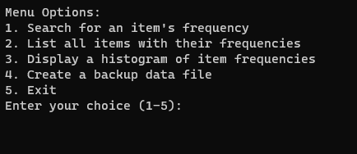

Figure 1: Shows the starting menu when the program first runs

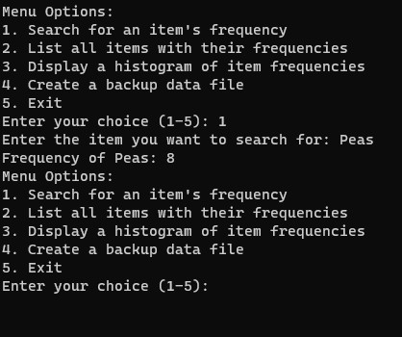

Figure 2: Show the action of inputting an item and what it does

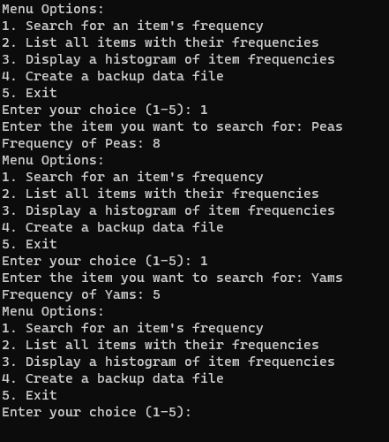

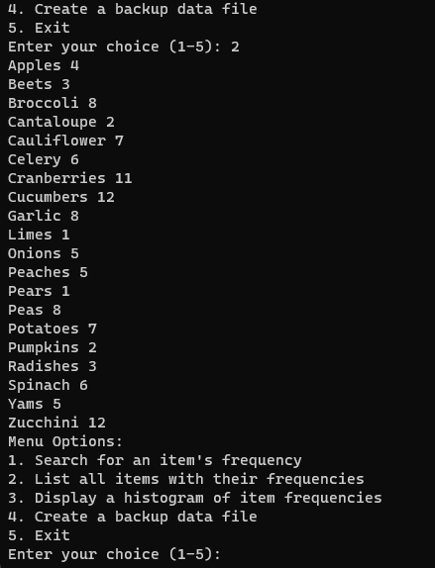

Figure 3: Shows the action of inputting ‘2’ to list all items and their frequencies

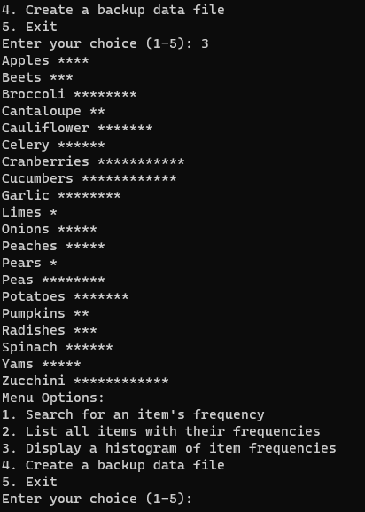

Figure 4: Shows the action of inputting ‘3’ which displays a histogram of the item frequencies

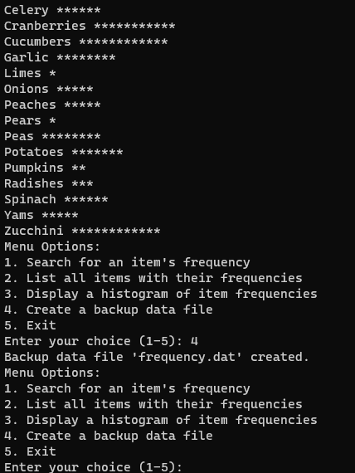

Figure 5: Shows the action of inputting ‘4’ which creates a backup ‘dat’ file

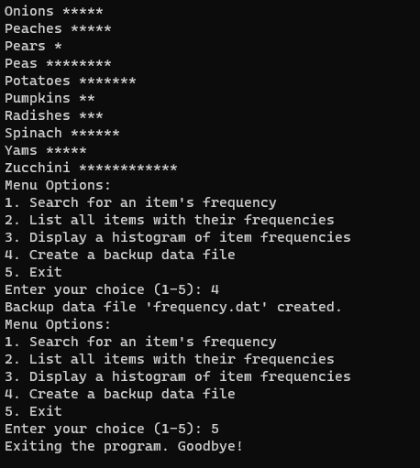

Figure 6: Shows the input of ‘5’ which exits and ends the program